R Notebook

John Kamau

02/08/2019

# Q6 Did the meeting start late?

|  |  |  |  |  |  |  |
| --- | --- | --- | --- | --- | --- | --- |
| Late | Mali_1 | Mali_2 | Mali_3 | Uganda_1 | Uganda_2 | Uganda_3 |
| Yes | 92 | 78 | 39 | 71 | 59 | 37 |
| No | 71 | 78 | 66 | 51 | 41 | 12 |
| Respondents | 163 | 156 | 105 | 122 | 100 | 49 |
| Late | Mali_1 | Mali_2 | Mali_3 | Uganda_1 | Uganda_2 | Uganda_3 |
| Yes | 0.56441717791411 | 0.5 | 0.371428571428571 | 0.581967213114754 | 0.59 | 0.755102040816326 |
| No | 0.43558282208589 | 0.5 | 0.628571428571429 | 0.418032786885246 | 0.41 | 0.244897959183673 |
| Percentage | 1 | 1 | 1 | 1 | 1 | 1 |

# Q7 How many minutes too late did the meeting start?

## [1] "G1"

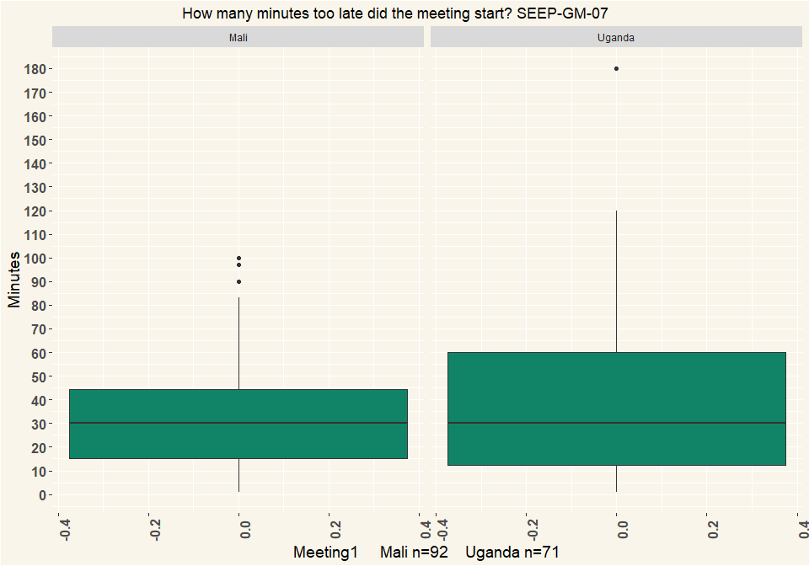

## [1] "G2"

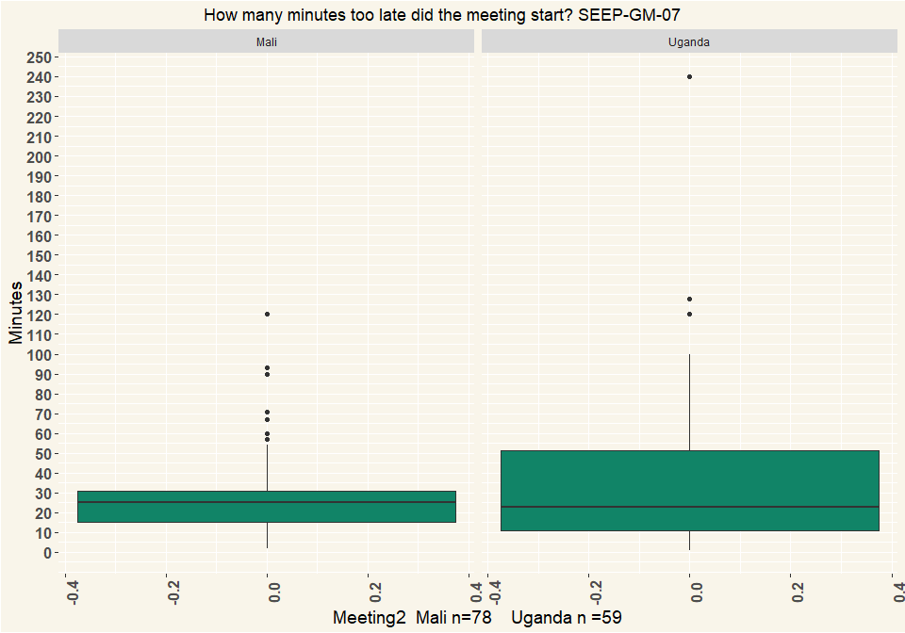

## [1] "G3"

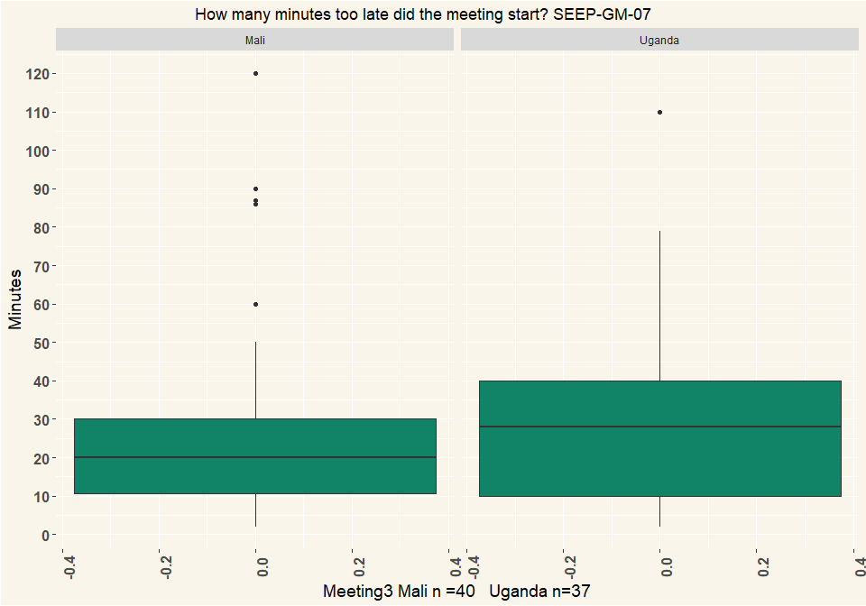

# Q8 What was the reason/were the reasons the meeting started late?

|  |  |  |  |  |  |  |
| --- | --- | --- | --- | --- | --- | --- |
| Late | Mali_G1 | Mali_G2 | Mali_G3 | Uganda_G1 | Uganda_G2 | Uganda_G3 |
| Chairperson or other committee members were late | 4 | 11 | 8 | 14 | 18 | 13 |
| Members were late | 74 | 63 | 39 | 52 | 42 | 27 |
| The location was not ready yet | 1 | 5 | 7 | 6 | 5 | 1 |
| People were first talking and discussing | 3 | 7 | 1 | 8 | 11 | 7 |
| Nobody paid attention to the time | 2 | 2 | NA | 11 | 8 | 3 |
| Other (specify) | 13 | 5 | NA | 12 | 7 | 3 |
| Respondents | 97 | 93 | 55 | 103 | 91 | 54 |
| Late | Mali_G1 | Mali_G2 | Mali_G3 | Uganda_G1 | Uganda_G2 | Uganda_G3 |
| Chairperson or other committee members were late | 0.0412 | 0.118 | 0.145 | 0.136 | 0.198 | 0.241 |
| Members were late | 0.763 | 0.677 | 0.709 | 0.505 | 0.462 | 0.5 |
| The location was not ready yet | 0.0103 | 0.0538 | 0.127 | 0.0583 | 0.0549 | 0.0185 |
| People were first talking and discussing | 0.0309 | 0.0753 | 0.0182 | 0.0777 | 0.121 | 0.13 |
| Nobody paid attention to the time | 0.0206 | 0.0215 | NA | 0.107 | 0.0879 | 0.0556 |
| Other (specify) | 0.134 | 0.0538 | NA | 0.117 | 0.0769 | 0.0556 |
| Percentage | 1 | 1 | 1 | 1 | 1 | 1 |

# Q9 Did the meeting start with a specific ritual, like a prayer, a song, a speech? (Multiple Choice)

|  |  |  |  |  |  |  |
| --- | --- | --- | --- | --- | --- | --- |
| Ritual | Mali_G1 | Mali_G2 | Mali_G3 | Uganda_G1 | Uganda_G2 | Uganda_G3 |
| A song or dance | 19 | 22 | 11 | NA | 1 | 1 |
| A prayer | 27 | 30 | 18 | 81 | 71 | 33 |
| A speech | 40 | 51 | 35 | 48 | 34 | 9 |
| Reciting group rules/constitution | 82 | 102 | 77 | 2 | NA | 1 |
| Other (specify) | 22 | 2 | 9 | 21 | 11 | 9 |
| Respondents | 190 | 207 | 150 | 152 | 117 | 53 |
| Ritual | Mali_G1 | Mali_G2 | Mali_G3 | Uganda_G1 | Uganda_G2 | Uganda_G3 |
| A song or dance | 0.1 | 0.106 | 0.0733 | NA | 0.00855 | 0.0189 |
| A prayer | 0.142 | 0.145 | 0.12 | 0.533 | 0.607 | 0.623 |
| A speech | 0.211 | 0.246 | 0.233 | 0.316 | 0.291 | 0.17 |
| Reciting group rules/constitution | 0.432 | 0.493 | 0.513 | 0.0132 | NA | 0.0189 |
| Other (specify) | 0.116 | 0.00966 | 0.06 | 0.138 | 0.094 | 0.17 |
| Percentage | 1 | 1 | 1 | 1 | 1 | 1 |

# Q10 Did the meeting have a round of questions or comment where each member got a chance to speak?

|  |  |  |  |  |  |  |
| --- | --- | --- | --- | --- | --- | --- |
| Questions | Mali_G1 | Mali_G2 | Mali_G3 | Uganda_G1 | Uganda_G2 | Uganda_G3 |
| Yes | 155 | 133 | 89 | 70 | 48 | 23 |
| No | 8 | 23 | 16 | 52 | 50 | 26 |
| Other (specify) | NA | NA | NA | NA | 1 | NA |
| I don’t know | NA | NA | NA | NA | 1 | NA |
| Respondents | 163 | 156 | 105 | 122 | 100 | 49 |
| Questions | Mali_G1 | Mali_G2 | Mali_G3 | Uganda_G1 | Uganda_G2 | Uganda_G3 |
| Yes | 0.951 | 0.853 | 0.848 | 0.574 | 0.48 | 0.469 |
| No | 0.0491 | 0.147 | 0.152 | 0.426 | 0.5 | 0.531 |
| Other (specify) | NA | NA | NA | NA | 0.01 | NA |
| I don’t know | NA | NA | NA | NA | 0.01 | NA |
| Percentage | 1 | 1 | 1 | 1 | 1 | 1 |

# Q11 How were the savings collected?

|  |  |  |  |  |  |  |
| --- | --- | --- | --- | --- | --- | --- |
| Savings | Mali_G1 | Mali_G2 | Mali_G3 | Uganda_G1 | Uganda_G2 | Uganda_G3 |
| One member was called at a time | 85 | 84 | 55 | 119 | 95 | 49 |
| All members put their savings at the same time | 40 | 48 | 32 | NA | 4 | NA |
| It was supposed to be one member at a time but it was chaotic and some doing at same time | NA | NA | NA | 3 | 1 | NA |
| Other (specify) | 38 | 24 | 18 | NA | NA | NA |
| Respondents | 163 | 156 | 105 | 122 | 100 | 49 |
| Savings | Mali_G1 | Mali_G2 | Mali_G3 | Uganda_G1 | Uganda_G2 | Uganda_G3 |
| One member was called at a time | 0.521 | 0.538 | 0.524 | 0.975 | 0.95 | 1 |
| All members put their savings at the same time | 0.245 | 0.308 | 0.305 | NA | 0.04 | NA |
| It was supposed to be one member at a time but it was chaotic and some doing at same time | NA | NA | NA | 0.0246 | 0.01 | NA |
| Other (specify) | 0.233 | 0.154 | 0.171 | NA | NA | NA |
| Percentage | 1 | 1 | 1 | 1 | 1 | 1 |

# Q12 Did each savings amount get counted?

|  |  |  |  |  |  |  |
| --- | --- | --- | --- | --- | --- | --- |
| Savings | Mali_G1 | Mali_G2 | Mali_G3 | Uganda_G1 | Uganda_G2 | Uganda_G3 |
| Yes, each savings amount got counted and the total was announced by a money counter | 151 | 150 | 103 | 104 | 95 | 47 |
| Yes, each savings amount got counted but total not announced | 10 | 3 | 1 | 16 | 4 | 2 |
| No, savings was not counted but put in view of others without counting | 2 | 2 | 1 | 2 | 1 | NA |
| No, savings was not counted and not in view of others | NA | 1 | NA | NA | NA | NA |
| Respondents | 163 | 156 | 105 | 122 | 100 | 49 |
| Savings | Mali_G1 | Mali_G2 | Mali_G3 | Uganda_G1 | Uganda_G2 | Uganda_G3 |
| Yes, each savings amount got counted and the total was announced by a money counter | 0.926 | 0.962 | 0.981 | 0.852 | 0.95 | 0.959 |
| Yes, each savings amount got counted but total not announced | 0.0613 | 0.0192 | 0.00952 | 0.131 | 0.04 | 0.0408 |
| No, savings was not counted but put in view of others without counting | 0.0123 | 0.0128 | 0.00952 | 0.0164 | 0.01 | NA |
| No, savings was not counted and not in view of others | NA | 0.00641 | NA | NA | NA | NA |
| Percentage | 1 | 1 | 1 | 1 | 1 | 1 |

# Q14 How were the savings recorded?

|  |  |  |  |  |  |  |
| --- | --- | --- | --- | --- | --- | --- |
| Savings | Mali_G1 | Mali_G2 | Mali_G3 | Uganda_G1 | Uganda_G2 | Uganda_G3 |
| Written record of each member’s savings | 105 | 122 | 59 | 118 | 95 | 43 |
| Some written system but only for total | 22 | 18 | 12 | 1 | 4 | 1 |
| Memory based system but only for total | 12 | 7 | 8 | NA | NA | 1 |
| Other (specify) | 16 | 8 | 10 | NA | NA | NA |
| Respondents | 155 | 155 | 89 | 119 | 99 | 45 |
| Savings | Mali_G1 | Mali_G2 | Mali_G3 | Uganda_G1 | Uganda_G2 | Uganda_G3 |
| Written record of each member’s savings | 0.677 | 0.787 | 0.663 | 0.992 | 0.96 | 0.956 |
| Some written system but only for total | 0.142 | 0.116 | 0.135 | 0.0084 | 0.0404 | 0.0222 |
| Memory based system but only for total | 0.0774 | 0.0452 | 0.0899 | NA | NA | 0.0222 |
| Other (specify) | 0.103 | 0.0516 | 0.112 | NA | NA | NA |
| Percentage | 1 | 1 | 1 | 1 | 1 | 1 |

# Q15 Do members have an individual pass-book?

|  |  |  |  |  |  |  |
| --- | --- | --- | --- | --- | --- | --- |
| Passbook | Mali_G1 | Mali_G2 | Mali_G3 | Uganda_G1 | Uganda_G2 | Uganda_G3 |
| Yes, and they keep it themselves and bring it to the meeting | 25 | 23 | 29 | 23 | 9 | 2 |
| Yes, but it is kept in the group | 3 | NA | NA | 84 | 74 | 37 |
| No, no passbooks | 135 | 133 | 76 | 13 | 14 | 8 |
| Other (specify) | NA | NA | NA | 2 | 3 | 2 |
| Respondents | 163 | 156 | 105 | 122 | 100 | 49 |
| Passbook | Mali_G1 | Mali_G2 | Mali_G3 | Uganda_G1 | Uganda_G2 | Uganda_G3 |
| Yes, and they keep it themselves and bring it to the meeting | 0.153 | 0.147 | 0.276 | 0.189 | 0.09 | 0.0408 |
| Yes, but it is kept in the group | 0.0184 | NA | NA | 0.689 | 0.74 | 0.755 |
| No, no passbooks | 0.828 | 0.853 | 0.724 | 0.107 | 0.14 | 0.163 |
| Other (specify) | NA | NA | NA | 0.0164 | 0.03 | 0.0408 |
| Percentage | 1 | 1 | 1 | 1 | 1 | 1 |

# Q16 Did the savings get recorded in the individual pass-books?

|  |  |  |  |  |  |  |
| --- | --- | --- | --- | --- | --- | --- |
| Passbook | Mali_G1 | Mali_G2 | Mali_G3 | Uganda_G1 | Uganda_G2 | Uganda_G3 |
| Yes, with stamps for each share bought | 1 | NA | 1 | 100 | 77 | 35 |
| Yes, with a pen indicating each share bought | 23 | 23 | 12 | 6 | 7 | 4 |
| Yes, amounts written out | 1 | NA | NA | 1 | 1 | 2 |
| Other (specify) | 3 | NA | 17 | 2 | 2 | NA |
| Respondents | 28 | 23 | 30 | 109 | 87 | 41 |
| Passbook | Mali_G1 | Mali_G2 | Mali_G3 | Uganda_G1 | Uganda_G2 | Uganda_G3 |
| Yes, with stamps for each share bought | 0.0357 | NA | 0.0333 | 0.917 | 0.885 | 0.854 |
| Yes, with a pen indicating each share bought | 0.821 | 1 | 0.4 | 0.055 | 0.0805 | 0.0976 |
| Yes, amounts written out | 0.0357 | NA | NA | 0.00917 | 0.0115 | 0.0488 |
| Other (specify) | 0.107 | NA | 0.567 | 0.0183 | 0.023 | NA |
| Percentage | 1 | 1 | 1 | 1 | 1 | 1 |

# Q17 Did any of the group-members not save at all? How many did not save at all?

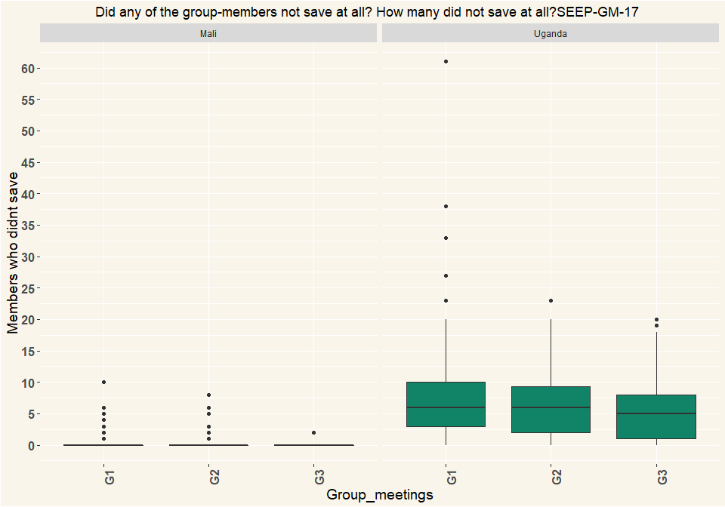

|  |  |  |  |
| --- | --- | --- | --- |
| Country | G1 | G2 | G3 |
| Mali | 163 | 156 | 105 |
| Uganda | 122 | 100 | 49 |

# Q18 Who did not save?

|  |  |  |  |  |  |  |
| --- | --- | --- | --- | --- | --- | --- |
| Non_savers | Mali_G1 | Mali_G2 | Mali_G3 | Uganda_G1 | Uganda_G2 | Uganda_G3 |
| People who were absent | 11 | 13 | 3 | 76 | 62 | 26 |
| People present | 3 | NA | NA | NA | NA | 1 |
| Both absent and present people | 4 | 3 | 1 | 30 | 20 | 11 |
| Respondents | 18 | 16 | 4 | 106 | 82 | 38 |
| Non_savers | Mali_G1 | Mali_G2 | Mali_G3 | Uganda_G1 | Uganda_G2 | Uganda_G3 |
| People who were absent | 0.611 | 0.812 | 0.75 | 0.717 | 0.756 | 0.684 |
| People present | 0.167 | NA | NA | NA | NA | 0.0263 |
| Both absent and present people | 0.222 | 0.188 | 0.25 | 0.283 | 0.244 | 0.289 |
| NA | 1 | 1 | 1 | 1 | 1 | 1 |

# Q19 Was it considered against the rules that some people did not save?

|  |  |  |  |  |  |  |
| --- | --- | --- | --- | --- | --- | --- |
| Non_savers | Mali_G1 | Mali_G2 | Mali_G3 | Uganda_G1 | Uganda_G2 | Uganda_G3 |
| Yes, very much | 13 | 12 | 6 | 23 | 18 | 8 |
| Yes, but no big deal made of it | 3 | NA | NA | 39 | 22 | 11 |
| No, did not seem to | 2 | 4 | NA | 35 | 40 | 18 |
| No, it was clearly according to the rules, it is allowed to miss savings | NA | NA | NA | 7 | 1 | NA |
| Other (specify) | NA | NA | NA | 2 | 1 | 1 |
| Respondents | 18 | 16 | 6 | 106 | 82 | 38 |
| Non_savers | Mali_G1 | Mali_G2 | Mali_G3 | Uganda_G1 | Uganda_G2 | Uganda_G3 |
| Yes, very much | 0.722 | 0.75 | 1 | 0.217 | 0.22 | 0.211 |
| Yes, but no big deal made of it | 0.167 | NA | NA | 0.368 | 0.268 | 0.289 |
| No, did not seem to | 0.111 | 0.25 | NA | 0.33 | 0.488 | 0.474 |
| No, it was clearly according to the rules, it is allowed to miss savings | NA | NA | NA | 0.066 | 0.0122 | NA |
| Other (specify) | NA | NA | NA | 0.0189 | 0.0122 | 0.0263 |
| Percentage | 1 | 1 | 1 | 1 | 1 | 1 |

# Q20 Did the group give out loans at the meeting?

|  |  |  |  |  |  |  |
| --- | --- | --- | --- | --- | --- | --- |
| Loans | Mali_G1 | Mali_G2 | Mali_G3 | Uganda_G1 | Uganda_G2 | Uganda_G3 |
| Yes | 64 | 71 | 49 | 85 | 52 | 29 |
| No | 99 | 85 | 56 | 35 | 48 | 20 |
| Other (specify) | NA | NA | NA | 2 | NA | NA |
| Respondents | 163 | 156 | 105 | 122 | 100 | 49 |
| Loans | Mali_G1 | Mali_G2 | Mali_G3 | Uganda_G1 | Uganda_G2 | Uganda_G3 |
| Yes | 0.393 | 0.455 | 0.467 | 0.697 | 0.52 | 0.592 |
| No | 0.607 | 0.545 | 0.533 | 0.287 | 0.48 | 0.408 |
| Other (specify) | NA | NA | NA | 0.0164 | NA | NA |
| Percentage | 1 | 1 | 1 | 1 | 1 | 1 |

# Q22 Did people request loans or were they offered loans?

|  |  |  |  |  |  |  |
| --- | --- | --- | --- | --- | --- | --- |
| Loans | Mali_G1 | Mali_G2 | Mali_G3 | Uganda_G1 | Uganda_G2 | Uganda_G3 |
| Each member had the chance to request for a loan | 61 | 71 | 48 | 72 | 48 | 23 |
| Specific members were asked whether they wanted a loan | 2 | NA | 2 | 3 | 3 | 3 |
| Specific members were assigned to get a loan | 1 | NA | NA | 6 | 1 | 2 |
| Other (specify) | NA | NA | NA | 5 | 1 | 1 |
| Respondents | 64 | 71 | 50 | 86 | 53 | 29 |
| Loans | Mali_G1 | Mali_G2 | Mali_G3 | Uganda_G1 | Uganda_G2 | Uganda_G3 |
| Each member had the chance to request for a loan | 0.953 | 1 | 0.96 | 0.837 | 0.906 | 0.793 |
| Specific members were asked whether they wanted a loan | 0.0312 | NA | 0.04 | 0.0349 | 0.0566 | 0.103 |
| Specific members were assigned to get a loan | 0.0156 | NA | NA | 0.0698 | 0.0189 | 0.069 |
| Other (specify) | NA | NA | NA | 0.0581 | 0.0189 | 0.0345 |
| Percentage | 1 | 1 | 1 | 1 | 1 | 1 |

# Q23 How were the loan allocated?

|  |  |  |  |  |  |  |
| --- | --- | --- | --- | --- | --- | --- |
| Loans | Mali_G1 | Mali_G2 | Mali_G3 | Uganda_G1 | Uganda_G2 | Uganda_G3 |
| There were more applicants for loans than available loans, so only some were successful at getting a loan | 35 | 31 | 21 | 39 | 27 | 13 |
| All those requesting a loan received a loan | 28 | 40 | 28 | 42 | 24 | 15 |
| Loans were given (it was assumed all wanted a loan) | NA | NA | 1 | NA | NA | NA |
| Other (specify) | 1 | NA | NA | 5 | 2 | 1 |
| Respondents | 64 | 71 | 50 | 86 | 53 | 29 |
| Loans | Mali_G1 | Mali_G2 | Mali_G3 | Uganda_G1 | Uganda_G2 | Uganda_G3 |
| There were more applicants for loans than available loans, so only some were successful at getting a loan | 0.547 | 0.437 | 0.42 | 0.453 | 0.509 | 0.448 |
| All those requesting a loan received a loan | 0.438 | 0.563 | 0.56 | 0.488 | 0.453 | 0.517 |
| Loans were given (it was assumed all wanted a loan) | NA | NA | 0.02 | NA | NA | NA |
| Other (specify) | 0.0156 | NA | NA | 0.0581 | 0.0377 | 0.0345 |
| Percentage | 1 | 1 | 1 | 1 | 1 | 1 |

# Q24 Did loan recipients need to meet financial criteria?

|  |  |  |  |  |  |  |
| --- | --- | --- | --- | --- | --- | --- |
| Loans | Mali_G1 | Mali_G2 | Mali_G3 | Uganda_G1 | Uganda_G2 | Uganda_G3 |
| Yes, record keeper verified that loans were within a specified multiple of member’s savings. | 27 | 21 | 11 | 59 | 39 | 17 |
| Yes, loan eligibility depended on previous repayment or other criteria | 13 | 9 | 9 | 21 | 7 | 7 |
| No, anyone could take a loan | 24 | 40 | 30 | 5 | 6 | 5 |
| Other(specify) | NA | 1 | NA | 1 | 1 | NA |
| Respondents | 64 | 71 | 50 | 86 | 53 | 29 |
| Loans | Mali_G1 | Mali_G2 | Mali_G3 | Uganda_G1 | Uganda_G2 | Uganda_G3 |
| Yes, record keeper verified that loans were within a specified multiple of member’s savings. | 0.422 | 0.296 | 0.22 | 0.686 | 0.736 | 0.586 |
| Yes, loan eligibility depended on previous repayment or other criteria | 0.203 | 0.127 | 0.18 | 0.244 | 0.132 | 0.241 |
| No, anyone could take a loan | 0.375 | 0.563 | 0.6 | 0.0581 | 0.113 | 0.172 |
| Other(specify) | NA | 0.0141 | NA | 0.0116 | 0.0189 | NA |
| Percentage | 1 | 1 | 1 | 1 | 1 | 1 |

# Q25 Were any rules about loan purpose applied or discussed?

|  |  |  |  |  |  |  |
| --- | --- | --- | --- | --- | --- | --- |
| Loans | Mali_G1 | Mali_G2 | Mali_G3 | Uganda_G1 | Uganda_G2 | Uganda_G3 |
| Yes, loan purpose had to be productive | 16 | 4 | 20 | 35 | 18 | 3 |
| Yes, loan purpose had to be useful (could be productive, emergencies, school fees…) | 23 | 28 | 13 | 8 | 2 | NA |
| loan purpose was mentioned but no criteria seemed required | 5 | 10 | 1 | 11 | 8 | 5 |
| Loan purpose was not discussed | 20 | 29 | 16 | 30 | 25 | 19 |
| Other (specify) | NA | NA | NA | 2 | NA | 2 |
| Respondents | 64 | 71 | 50 | 86 | 53 | 29 |
| Loans | Mali_G1 | Mali_G2 | Mali_G3 | Uganda_G1 | Uganda_G2 | Uganda_G3 |
| Yes, loan purpose had to be productive | 0.25 | 0.0563 | 0.4 | 0.407 | 0.34 | 0.103 |
| Yes, loan purpose had to be useful (could be productive, emergencies, school fees…) | 0.359 | 0.394 | 0.26 | 0.093 | 0.0377 | NA |
| loan purpose was mentioned but no criteria seemed required | 0.0781 | 0.141 | 0.02 | 0.128 | 0.151 | 0.172 |
| Loan purpose was not discussed | 0.312 | 0.408 | 0.32 | 0.349 | 0.472 | 0.655 |
| Other (specify) | NA | NA | NA | 0.0233 | NA | 0.069 |
| Percentage | 1 | 1 | 1 | 1 | 1 | 1 |

# Q26 Who made the loan approval decision?

|  |  |  |  |  |  |  |
| --- | --- | --- | --- | --- | --- | --- |
| Loans | Mali_G1 | Mali_G2 | Mali_G3 | Uganda_G1 | Uganda_G2 | Uganda_G3 |
| The chairperson | 8 | 4 | 4 | 5 | 5 | 1 |
| The committee | 27 | 23 | 12 | 19 | 13 | 17 |
| The entire savings-group (voting) | 8 | 5 | 13 | 27 | 16 | 5 |
| Just by discussion, nobody decided | 6 | 15 | 7 | 23 | 13 | 5 |
| All requests automatically approved | 14 | 24 | 14 | 10 | 6 | 1 |
| Other (specify) | 1 | NA | NA | 2 | NA | NA |
| Respondents | 64 | 71 | 50 | 86 | 53 | 29 |
| Loans | Mali_G1 | Mali_G2 | Mali_G3 | Uganda_G1 | Uganda_G2 | Uganda_G3 |
| The chairperson | 0.125 | 0.0563 | 0.08 | 0.0581 | 0.0943 | 0.0345 |
| The committee | 0.422 | 0.324 | 0.24 | 0.221 | 0.245 | 0.586 |
| The entire savings-group (voting) | 0.125 | 0.0704 | 0.26 | 0.314 | 0.302 | 0.172 |
| Just by discussion, nobody decided | 0.0938 | 0.211 | 0.14 | 0.267 | 0.245 | 0.172 |
| All requests automatically approved | 0.219 | 0.338 | 0.28 | 0.116 | 0.113 | 0.0345 |
| Other (specify) | 0.0156 | NA | NA | 0.0233 | NA | NA |
| Percentage | 1 | 1 | 1 | 1 | 1 | 1 |

# Q27 What is the interest rate charged for loans given at the meeting?

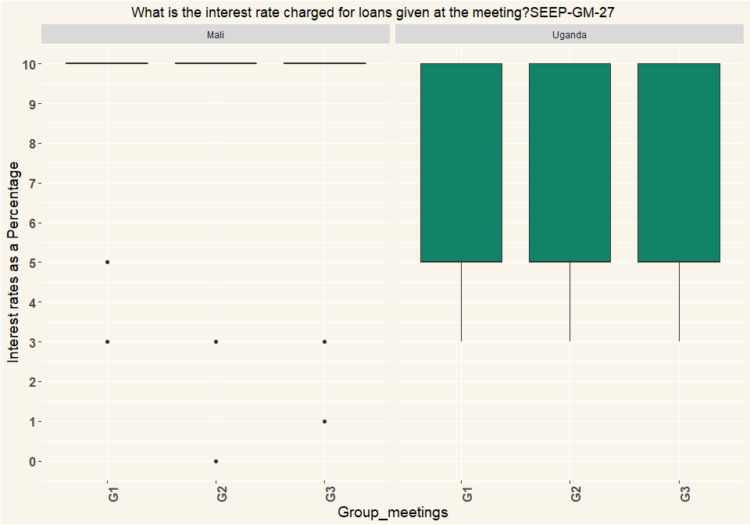

|  |  |  |  |
| --- | --- | --- | --- |
| Country | G1 | G2 | G3 |
| Mali | 64 | 71 | 50 |
| Uganda | 86 | 53 | 29 |

# Q28 how is that calculated?

|  |  |  |  |  |  |  |
| --- | --- | --- | --- | --- | --- | --- |
| Calculated | Mali_G1 | Mali_G2 | Mali_G3 | Uganda_G1 | Uganda_G2 | Uganda_G3 |
| One time, on amount borrowed. | 4 | 11 | 3 | 13 | 4 | 1 |
| Monthly, for period borrowed. | 57 | 58 | 46 | 46 | 26 | 9 |
| Recalculated each month on declining balance of loan | NA | 2 | 1 | 27 | 22 | 18 |
| Other: | 3 | NA | NA | NA | 1 | 1 |
| Respondents | 64 | 71 | 50 | 86 | 53 | 29 |
| Calculated | Mali_G1 | Mali_G2 | Mali_G3 | Uganda_G1 | Uganda_G2 | Uganda_G3 |
| One time, on amount borrowed. | 0.0625 | 0.155 | 0.06 | 0.151 | 0.0755 | 0.0345 |
| Monthly, for period borrowed. | 0.891 | 0.817 | 0.92 | 0.535 | 0.491 | 0.31 |
| Recalculated each month on declining balance of loan | NA | 0.0282 | 0.02 | 0.314 | 0.415 | 0.621 |
| Other: | 0.0469 | NA | NA | NA | 0.0189 | 0.0345 |
| Percentage | 1 | 1 | 1 | 1 | 1 | 1 |

# Q29 Did the group make any other decisions?

|  |  |  |  |  |  |  |
| --- | --- | --- | --- | --- | --- | --- |
| Decisions | Mali_G1 | Mali_G2 | Mali_G3 | Uganda_G1 | Uganda_G2 | Uganda_G3 |
| Allowing new members | 6 | 25 | 9 | 10 | 2 | 2 |
| Change rule(s) | 2 | 29 | 19 | 3 | 2 | NA |
| Dealing with defaulted loans | 4 | 7 | 9 | 2 | NA | 1 |
| Dealing with members leaving | NA | NA | NA | 7 | 2 | 1 |
| New rules | 24 | 22 | 4 | 4 | 2 | 1 |
| no other decision | 127 | 108 | 81 | 98 | 94 | 45 |
| Other issues (specify) | 3 | 6 | NA | 3 | 2 | NA |
| Respondents | 166 | 197 | 122 | 127 | 104 | 50 |
| Decisions | Mali_G1 | Mali_G2 | Mali_G3 | Uganda_G1 | Uganda_G2 | Uganda_G3 |
| Allowing new members | 0.0361 | 0.127 | 0.0738 | 0.0787 | 0.0192 | 0.04 |
| Change rule(s) | 0.012 | 0.147 | 0.156 | 0.0236 | 0.0192 | NA |
| Dealing with defaulted loans | 0.0241 | 0.0355 | 0.0738 | 0.0157 | NA | 0.02 |
| Dealing with members leaving | NA | NA | NA | 0.0551 | 0.0192 | 0.02 |
| New rules | 0.145 | 0.112 | 0.0328 | 0.0315 | 0.0192 | 0.02 |
| no other decision | 0.765 | 0.548 | 0.664 | 0.772 | 0.904 | 0.9 |
| Other issues (specify) | 0.0181 | 0.0305 | NA | 0.0236 | 0.0192 | NA |
| Percentage | 1 | 1 | 1 | 1 | 1 | 1 |

# Q31 Did the group have any conflict or disagreement in the meeting?

|  |  |  |  |  |  |  |
| --- | --- | --- | --- | --- | --- | --- |
| Conflict | Mali_G1 | Mali_G2 | Mali_G3 | Uganda_G1 | Uganda_G2 | Uganda_G3 |
| Yes, a large disagreement/conflict | 3 | NA | NA | 2 | NA | NA |
| Yes, just small disagreements | 4 | 5 | NA | 17 | 4 | 3 |
| No, I did not notice anything | 133 | 137 | 105 | 102 | 95 | 45 |
| Other (specify) | 23 | 14 | NA | 1 | 1 | 1 |
| Respondents | 163 | 156 | 105 | 122 | 100 | 49 |
| Conflict | Mali_G1 | Mali_G2 | Mali_G3 | Uganda_G1 | Uganda_G2 | Uganda_G3 |
| Yes, a large disagreement/conflict | 0.0184 | NA | NA | 0.0164 | NA | NA |
| Yes, just small disagreements | 0.0245 | 0.0321 | NA | 0.139 | 0.04 | 0.0612 |
| No, I did not notice anything | 0.816 | 0.878 | 1 | 0.836 | 0.95 | 0.918 |
| Other (specify) | 0.141 | 0.0897 | NA | 0.0082 | 0.01 | 0.0204 |
| Percentage | 1 | 1 | 1 | 1 | 1 | 1 |

# Q32 Was the conflict or disagreement resolved?

|  |  |  |  |  |  |  |
| --- | --- | --- | --- | --- | --- | --- |
| Conflict | Mali_G1 | Mali_G2 | Mali_G3 | Uganda_G1 | Uganda_G2 | Uganda_G3 |
| Yes | 8 | 3 | NA | 16 | 3 | 1 |
| More or less | NA | 2 | 2 | 2 | 1 | 2 |
| No | NA | NA | NA | 1 | NA | NA |
| Respondents | 8 | 5 | 2 | 19 | 4 | 3 |
| Conflict | Mali_G1 | Mali_G2 | Mali_G3 | Uganda_G1 | Uganda_G2 | Uganda_G3 |
| Yes | 1 | 0.6 | NA | 0.842 | 0.75 | 0.333 |
| More or less | NA | 0.4 | 1 | 0.105 | 0.25 | 0.667 |
| No | NA | NA | NA | 0.0526 | NA | NA |
| Percentage | 1 | 1 | 1 | 1 | 1 | 1 |

# Q35 At the end of the meeting, how many members had outstanding loans?

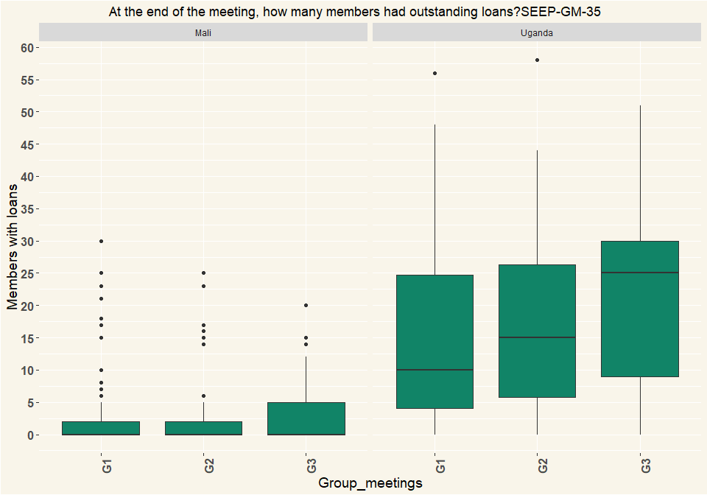

|  |  |  |  |
| --- | --- | --- | --- |
| Country | G1 | G2 | G3 |
| Mali | 163 | 156 | 105 |
| Uganda | 122 | 100 | 49 |

# Q36 Does the group have a social fund?

|  |  |  |  |  |  |  |
| --- | --- | --- | --- | --- | --- | --- |
| Fund | Mali_G1 | Mali_G2 | Mali_G3 | Uganda_G1 | Uganda_G2 | Uganda_G3 |
| Yes | 8 | 2 | NA | 99 | 81 | 39 |
| No | 155 | 154 | 105 | 23 | 19 | 10 |
| Respondents | 163 | 156 | 105 | 122 | 100 | 49 |
| Fund | Mali_G1 | Mali_G2 | Mali_G3 | Uganda_G1 | Uganda_G2 | Uganda_G3 |
| Yes | 0.0491 | 0.0128 | NA | 0.811 | 0.81 | 0.796 |
| No | 0.951 | 0.987 | 1 | 0.189 | 0.19 | 0.204 |
| Percentage | 1 | 1 | 1 | 1 | 1 | 1 |

# Q37 How is it funded?

|  |  |  |  |  |  |  |
| --- | --- | --- | --- | --- | --- | --- |
| Fund | Mali_G1 | Mali_G2 | Mali_G3 | Uganda_G1 | Uganda_G2 | Uganda_G3 |
| Members contribute a fixed amount every meeting | 3 | 2 | 2 | 80 | 65 | 26 |
| Members contribute up to a certain amount then contributions are frozen until it drops below that amount. | NA | NA | NA | 10 | 6 | 5 |
| Other: | 5 | NA | NA | 9 | 11 | 8 |
| Respondents | 8 | 2 | 2 | 99 | 82 | 39 |
| Fund | Mali_G1 | Mali_G2 | Mali_G3 | Uganda_G1 | Uganda_G2 | Uganda_G3 |
| Members contribute a fixed amount every meeting | 0.375 | 1 | 1 | 0.808 | 0.793 | 0.667 |
| Members contribute up to a certain amount then contributions are frozen until it drops below that amount. | NA | NA | NA | 0.101 | 0.0732 | 0.128 |
| Other: | 0.625 | NA | NA | 0.0909 | 0.134 | 0.205 |
| Percentage | 1 | 1 | 1 | 1 | 1 | 1 |

# Q38 What are the conditions to access the social fund?

|  |  |  |  |  |  |  |
| --- | --- | --- | --- | --- | --- | --- |
| Fund | Mali_G1 | Mali_G2 | Mali_G3 | Uganda_G1 | Uganda_G2 | Uganda_G3 |
| Members borrow with interest | 2 | NA | 1 | 2 | 1 | 1 |
| Members borrow without interest | 1 | NA | 1 | 92 | 74 | 35 |
| Members are given gifts that are not repaid | 5 | 1 | NA | 3 | 2 | 2 |
| Other: | NA | 1 | NA | 2 | 5 | 1 |
| Respondents | 8 | 2 | 2 | 99 | 82 | 39 |
| Fund | Mali_G1 | Mali_G2 | Mali_G3 | Uganda_G1 | Uganda_G2 | Uganda_G3 |
| Members borrow with interest | 0.25 | NA | 0.5 | 0.0202 | 0.0122 | 0.0256 |
| Members borrow without interest | 0.125 | NA | 0.5 | 0.929 | 0.902 | 0.897 |
| Members are given gifts that are not repaid | 0.625 | 0.5 | NA | 0.0303 | 0.0244 | 0.0513 |
| Other: | NA | 0.5 | NA | 0.0202 | 0.061 | 0.0256 |
| Percentage | 1 | 1 | 1 | 1 | 1 | 1 |

# Q39 What are the criteria for receiving social fund money?

|  |  |  |  |  |  |  |
| --- | --- | --- | --- | --- | --- | --- |
| Fund | Mali_G1 | Mali_G2 | Mali_G3 | Uganda_G1 | Uganda_G2 | Uganda_G3 |
| Specific list of uses only (such as death, birth, injury) | 5 | 1 | 2 | 27 | 20 | 14 |
| Request money for any social need | 3 | NA | NA | 68 | 61 | 24 |
| Other (specify) | NA | 1 | NA | 4 | 1 | 1 |
| Respondents | 8 | 2 | 2 | 99 | 82 | 39 |
| Fund | Mali_G1 | Mali_G2 | Mali_G3 | Uganda_G1 | Uganda_G2 | Uganda_G3 |
| Specific list of uses only (such as death, birth, injury) | 0.625 | 0.5 | 1 | 0.273 | 0.244 | 0.359 |
| Request money for any social need | 0.375 | NA | NA | 0.687 | 0.744 | 0.615 |
| Other (specify) | NA | 0.5 | NA | 0.0404 | 0.0122 | 0.0256 |
| Percentage | 1 | 1 | 1 | 1 | 1 | 1 |

# Q40 What is the balance of the Social Fund?

* Mali exchange rate 0.00169950
* Uganda exchange rate 0.000270226

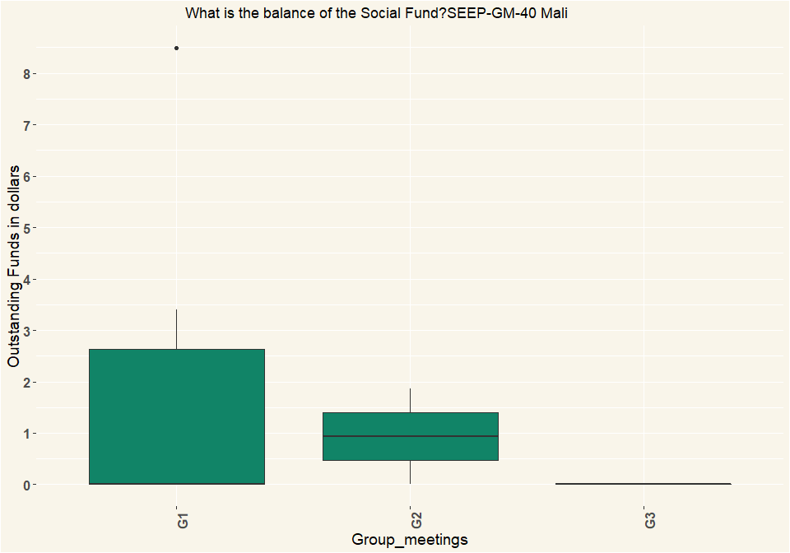

## [1] "Uganda"

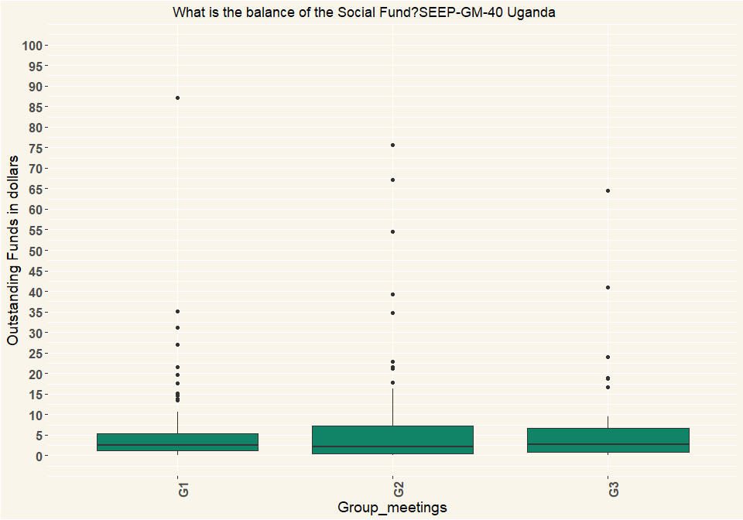

|  |  |  |  |
| --- | --- | --- | --- |
| Country | G1 | G2 | G3 |
| Mali | 8 | 2 | 2 |
| Uganda | 99 | 82 | 39 |

# Q41 Did any elections take place or get discussed for committee positions?

|  |  |  |  |  |  |  |
| --- | --- | --- | --- | --- | --- | --- |
| Elections | Mali_G1 | Mali_G2 | Mali_G3 | Uganda_G1 | Uganda_G2 | Uganda_G3 |
| No, not mentioned | 159 | 155 | 105 | 120 | 99 | 49 |
| Yes, discussed but planned for later | 2 | NA | NA | 1 | NA | NA |
| Yes, elections took place | 2 | 1 | NA | 1 | 1 | NA |
| Respondents | 163 | 156 | 105 | 122 | 100 | 49 |
| Elections | Mali_G1 | Mali_G2 | Mali_G3 | Uganda_G1 | Uganda_G2 | Uganda_G3 |
| No, not mentioned | 0.975 | 0.994 | 1 | 0.984 | 0.99 | 1 |
| Yes, discussed but planned for later | 0.0123 | NA | NA | 0.0082 | NA | NA |
| Yes, elections took place | 0.0123 | 0.00641 | NA | 0.0082 | 0.01 | NA |
| Percentage | 1 | 1 | 1 | 1 | 1 | 1 |

# Q44 How was the cash handled?

|  |  |  |  |  |  |  |
| --- | --- | --- | --- | --- | --- | --- |
| Cash | Mali_G1 | Mali_G2 | Mali_G3 | Uganda_G1 | Uganda_G2 | Uganda_G3 |
| Separate money counter/ separate bookkeeper/ separate treasurer, | 62 | 77 | 59 | 94 | 97 | 42 |
| Separate bookkeeper / treasurer | 91 | 76 | 46 | 23 | 2 | 5 |
| All done by same person | 10 | 3 | NA | 5 | 1 | 2 |
| Respondents | 163 | 156 | 105 | 122 | 100 | 49 |
| Cash | Mali_G1 | Mali_G2 | Mali_G3 | Uganda_G1 | Uganda_G2 | Uganda_G3 |
| Separate money counter/ separate bookkeeper/ separate treasurer, | 0.38 | 0.494 | 0.562 | 0.77 | 0.97 | 0.857 |
| Separate bookkeeper / treasurer | 0.558 | 0.487 | 0.438 | 0.189 | 0.02 | 0.102 |
| All done by same person | 0.0613 | 0.0192 | NA | 0.041 | 0.01 | 0.0408 |
| Percentage | 1 | 1 | 1 | 1 | 1 | 1 |

# Q45 Where was the cash money stored between previous and this meeting?

|  |  |  |  |  |  |  |
| --- | --- | --- | --- | --- | --- | --- |
| Cash | Mali_G1 | Mali_G2 | Mali_G3 | Uganda_G1 | Uganda_G2 | Uganda_G3 |
| In a box with several locks | 5 | 1 | NA | 107 | 78 | 37 |
| In a box with 1 lock | 155 | 153 | 104 | 2 | NA | NA |
| In another container that could be locked | NA | 1 | 1 | NA | NA | NA |
| In another container locked with one lock | NA | NA | NA | 4 | 10 | NA |
| No money was left (all lent out) | NA | NA | NA | 5 | 9 | 11 |
| Other (specify) | 2 | NA | NA | 4 | 3 | 1 |
| Respondents | 162 | 155 | 105 | 122 | 100 | 49 |
| Cash | Mali_G1 | Mali_G2 | Mali_G3 | Uganda_G1 | Uganda_G2 | Uganda_G3 |
| In a box with several locks | 0.0309 | 0.00645 | NA | 0.877 | 0.78 | 0.755 |
| In a box with 1 lock | 0.957 | 0.987 | 0.99 | 0.0164 | NA | NA |
| In another container that could be locked | NA | 0.00645 | 0.00952 | NA | NA | NA |
| In another container locked with one lock | NA | NA | NA | 0.0328 | 0.1 | NA |
| No money was left (all lent out) | NA | NA | NA | 0.041 | 0.09 | 0.224 |
| Other (specify) | 0.0123 | NA | NA | 0.0328 | 0.03 | 0.0204 |
| Percentage | 1 | 1 | 1 | 1 | 1 | 1 |

# Q46 Did any of the money from the group get stored in a (bank-)account or mobile money account between last and this meeting?

|  |  |  |  |  |  |  |
| --- | --- | --- | --- | --- | --- | --- |
| Cash | Mali_G1 | Mali_G2 | Mali_G3 | Uganda_G1 | Uganda_G2 | Uganda_G3 |
| Yes, all excess cash was stored in the account | 23 | 25 | 14 | 7 | 6 | 1 |
| Yes, some excess cash was stored in the account | 1 | NA | NA | 2 | 3 | NA |
| No, the excess cash was too little | 31 | 27 | 15 | 22 | 16 | 7 |
| No, it was not considered | 101 | 104 | 76 | 76 | 71 | 37 |
| Other (specify) | 6 | NA | NA | 13 | 2 | 1 |
| I don’t know | 1 | NA | NA | 2 | 2 | 3 |
| Respondents | 163 | 156 | 105 | 122 | 100 | 49 |
| Cash | Mali_G1 | Mali_G2 | Mali_G3 | Uganda_G1 | Uganda_G2 | Uganda_G3 |
| Yes, all excess cash was stored in the account | 0.141 | 0.16 | 0.133 | 0.0574 | 0.06 | 0.0204 |
| Yes, some excess cash was stored in the account | 0.00613 | NA | NA | 0.0164 | 0.03 | NA |
| No, the excess cash was too little | 0.19 | 0.173 | 0.143 | 0.18 | 0.16 | 0.143 |
| No, it was not considered | 0.62 | 0.667 | 0.724 | 0.623 | 0.71 | 0.755 |
| Other (specify) | 0.0368 | NA | NA | 0.107 | 0.02 | 0.0204 |
| I don’t know | 0.00613 | NA | NA | 0.0164 | 0.02 | 0.0612 |
| Percentage | 1 | 1 | 1 | 1 | 1 | 1 |

# Q47 Did any of the money from the group get stored in different places, e.g. different group members?

|  |  |  |  |  |  |  |
| --- | --- | --- | --- | --- | --- | --- |
| Cash | Mali_G1 | Mali_G2 | Mali_G3 | Uganda_G1 | Uganda_G2 | Uganda_G3 |
| All in one place | 135 | 133 | 92 | 107 | 89 | 42 |
| In two places | 27 | 23 | 13 | 8 | 8 | 5 |
| Other (specify) | 1 | NA | NA | 4 | 3 | 2 |
| I don’t know | NA | NA | NA | 3 | NA | NA |
| Respondents | 163 | 156 | 105 | 122 | 100 | 49 |
| Cash | Mali_G1 | Mali_G2 | Mali_G3 | Uganda_G1 | Uganda_G2 | Uganda_G3 |
| All in one place | 0.828 | 0.853 | 0.876 | 0.877 | 0.89 | 0.857 |
| In two places | 0.166 | 0.147 | 0.124 | 0.0656 | 0.08 | 0.102 |
| Other (specify) | 0.00613 | NA | NA | 0.0328 | 0.03 | 0.0408 |
| I don’t know | NA | NA | NA | 0.0246 | NA | NA |
| Percentage | 1 | 1 | 1 | 1 | 1 | 1 |

# Q48 How many members attended in total?

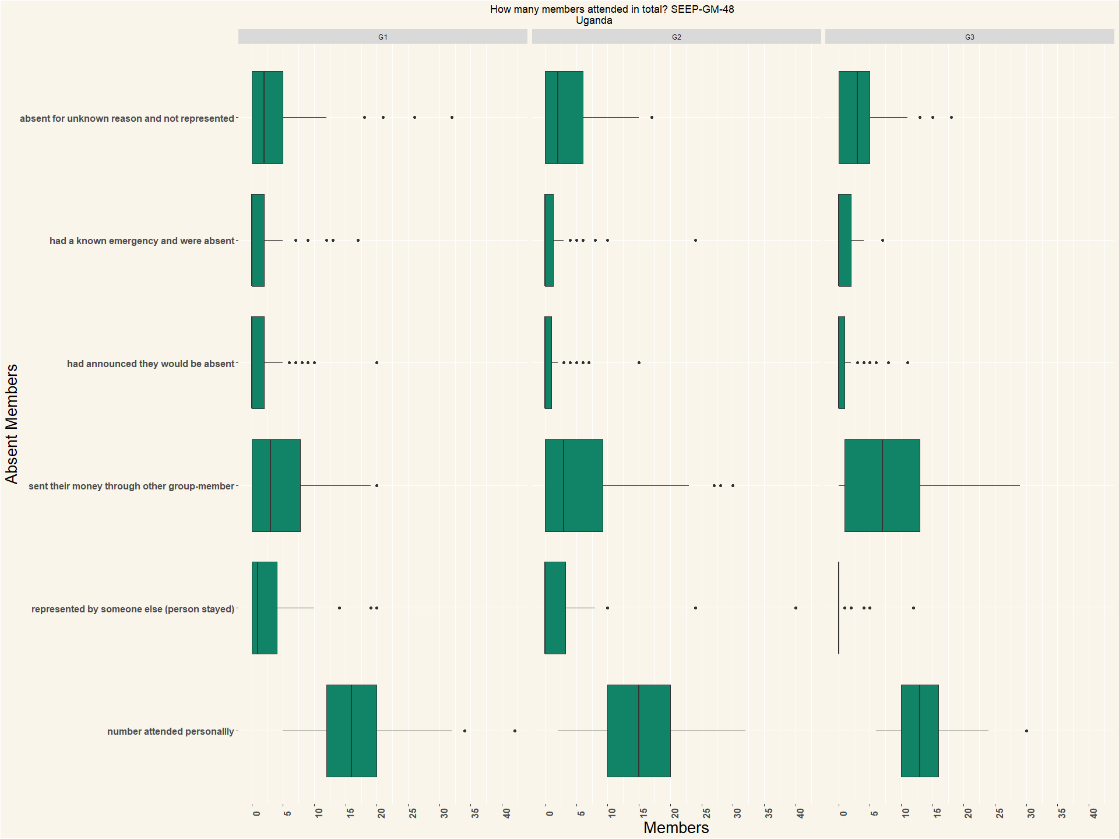

## [1] "Mali"

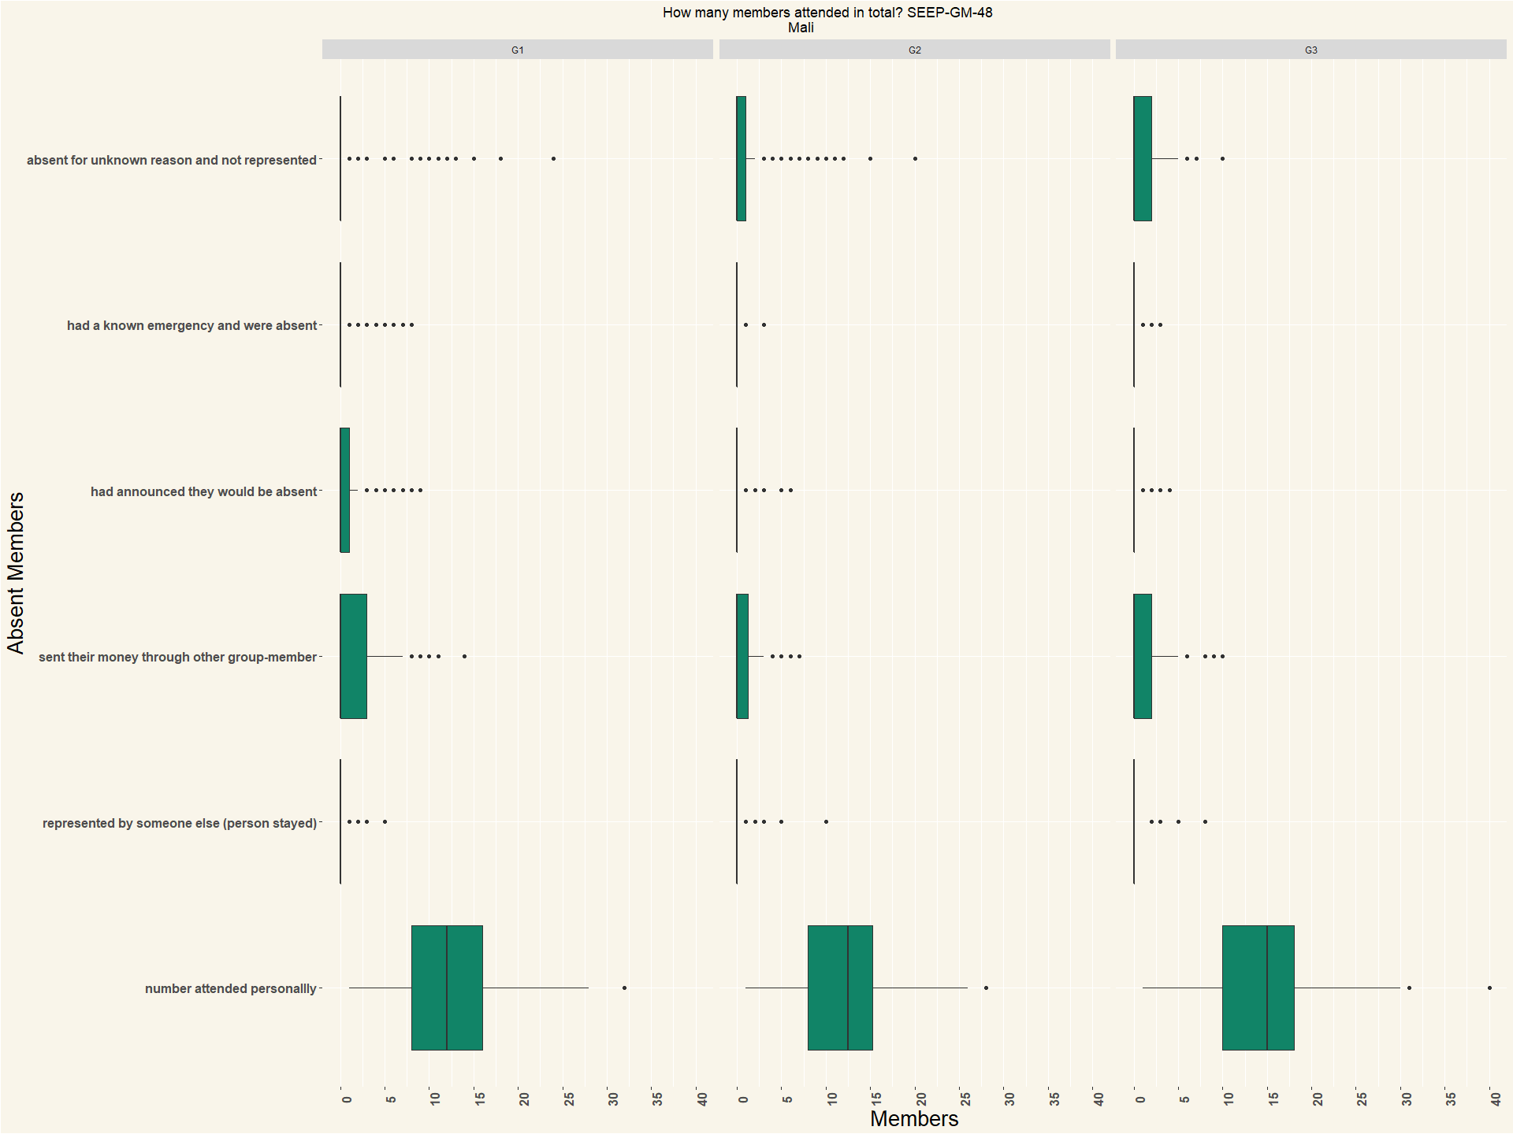

|  |  |  |  |
| --- | --- | --- | --- |
| Country | G1 | G2 | G3 |
| Mali | 163 | 156 | 105 |
| Uganda | 122 | 100 | 49 |

# Q49 How many members arrived after meeting started?

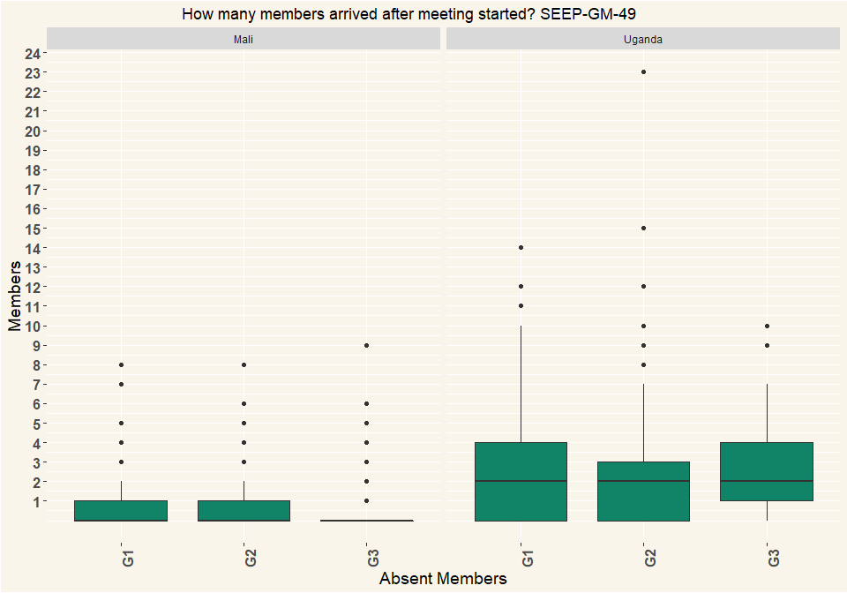

|  |  |  |  |
| --- | --- | --- | --- |
| Country | G1 | G2 | G3 |
| Mali | 163 | 156 | 105 |
| Uganda | 122 | 100 | 49 |

# Q50 Has the group experienced any of the following since last meeting up to end of this meeting?

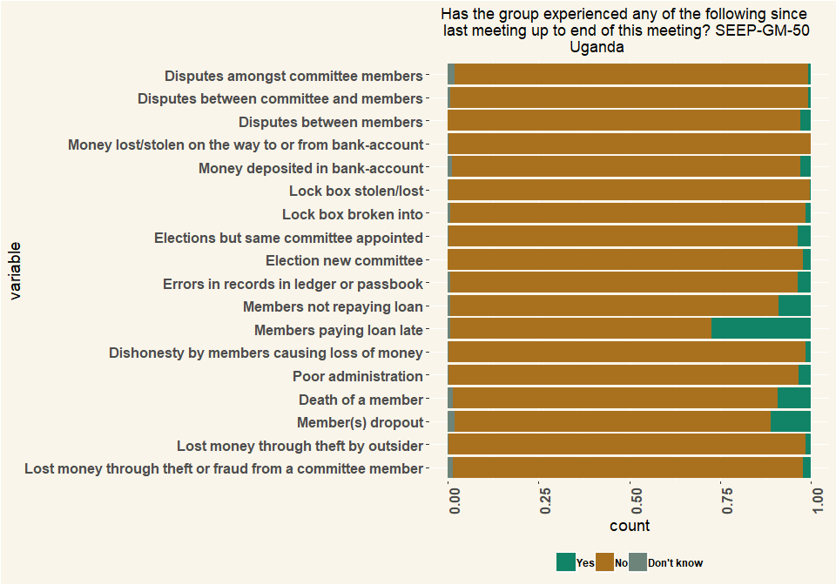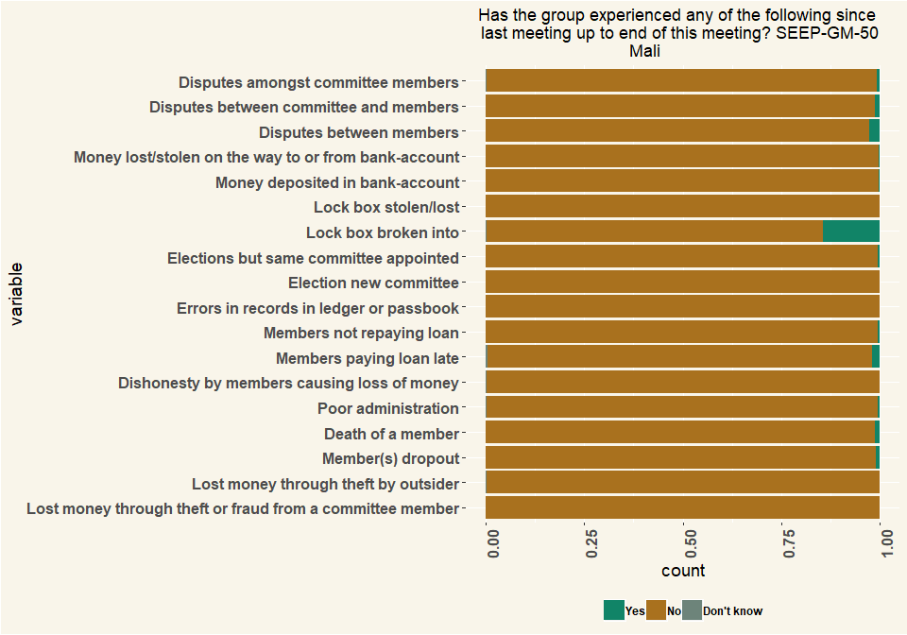

|  |  |  |  |
| --- | --- | --- | --- |
| Country | G1 | G2 | G3 |
| Mali | 163 | 156 | 105 |
| Uganda | 122 | 100 | 49 |

# Q51 Was any of the following used at the group-meeting? (Multiple Choice)

|  |  |  |  |  |  |  |
| --- | --- | --- | --- | --- | --- | --- |
| Tech | Mali_G1 | Mali_G2 | Mali_G3 | Uganda_G1 | Uganda_G2 | Uganda_G3 |
| Calculator on phone | 3 | 3 | 3 | 97 | 91 | 46 |
| Separate calculator | 29 | 27 | 17 | 37 | 34 | 13 |
| None | 132 | 127 | 86 | 8 | 2 | 1 |
| Respondents | 164 | 157 | 106 | 142 | 127 | 60 |
| Tech | Mali_G1 | Mali_G2 | Mali_G3 | Uganda_G1 | Uganda_G2 | Uganda_G3 |
| Calculator on phone | 0.0183 | 0.0191 | 0.0283 | 0.683 | 0.717 | 0.767 |
| Separate calculator | 0.177 | 0.172 | 0.16 | 0.261 | 0.268 | 0.217 |
| None | 0.805 | 0.809 | 0.811 | 0.0563 | 0.0157 | 0.0167 |
| Percentage | 1 | 1 | 1 | 1 | 1 | 1 |